DSE A 1: MICROBIAL BIOTECHNOLOGY
(PRACTICAL)

SEMESTER- 5
MCB-A-DSE-A-5-1-P

INDEX

Sl. No. | Date | Name of the Experiment | Page No. | Signature
1. |  | Study Yeast Cell Immobilization in Calcium Alginate Gels
2. |  | Study Immobilization by Sodium Alginate Method
3. |  | Isolation of Xylanase Producing Bacteria
4. |  | Isolation of Lipase Producing Bacteria
5. |  | Study of Yeast Single Cell Protein
6. |  | Study of Pigment Producing Microorganisms

Study Yeast Cell Immobilization in Calcium Alginate Gels

Principle
The term ‘immobilization’ was first proposed at the first enzyme engineering conference in 1971. Whole cell immobilization is an alternative to enzyme immobilization in which enzymes need to be isolated and purified in advance. Various types of cells, including bacteria yeasts, fungi, plant cell, microalgae, mammalian cells and insect cells, have been immobilized for improving bio manufacturing processes environmental applications and cell therapy. There are various methods available for immobilization of cell and enzyme absorption
• Covalent binding
• Cross matching
• Micro encapsulation
• Polymerization
• Gel entrapment
Advantages of cell and enzyme immobilization
Immobilization of whole cells can provide a favorable microenvironment, such as cell-cell contact, nutrient –product gradients, and pH gradients, so that the cellular activities of the immobilized cells can be enhanced. This technology offers many potential advantages over free cell systems, which can be summarized as follows:
• Higher cell densities maintained in a bioreactor
• Easier and lower –cost separation of cells from culture media
• Continuous cell culture process at high dilution rates readily established
• Enhanced resistance to shear stress for shear-sensitive cells, for example, plant and mammalian cells,
• Reduction of lag phase of cell growth
• Increased volumetric productivity
• Improved substrate utilization
• Reduced risk of microbial contamination
• Improved tolerance of cells from substrate and end-product inhibition
• Improved genetic stability

Materials Required:
- Yeast cell culture
- Yeast peptone Dextrose (YPD)/ Potato Dextrose broth (PDA) medium (for cultivation of Yeast cells)
- Sodium alginate solution (2.5% w/v in 0.1% NaCl)
- Calcium Chloride (CaCl₂) solution (0.05 N)
- Sterile distilled water
- Gluteraldehyde (2.5% v/v)
- Sucrose solution (1% w/v)
- Dinitrosalicylic acid
- Conical flasks
- Sterile 10ml pipette or syringe
- Glass beakers
- Beaker or glass column
- Test tubes
- Non absorbent cotton
- Inoculation needle
- Autoclave
- BOD incubator cum shaker
- Spirit lamp
- Laminar air flow chamber
- Spectrophotometer

Procedure:
- Prepare 25 ml of YPD/PDA medium in a 100ml conical flask, sterilize it and inoculate it with Saccharomyces cerevisiae culture.
- Incubate the flask at 30⁰C for 24hours at 100 rpm.
- Take 20 ml sodium alginate solution and to it add 3 ml of yeast cell culture in it. Mix properly and incubate at room temperature for 30 minutes then add 3 ml of gluteraldehyde solution and incubate at room temperature for 90 minutes.
- With the help of a sterile 10 ml pipette or syringe, drop wise add this mixture into the beaker containing 100 ml CaCl₂ solution and keep it undisturbed for 30 min.
- Filter out the beads with the help of normal filter paper.
- Wash the beads 2-3 times with sterile distilled water.
- Prepare another set of beads in the same procedure but instead of yeast cell culture add 3 ml of sterile distilled water. This would serve as the control.
- Load these beads (test as well as control) into two separate thoroughly washed glass columns/ beakers.
- Add 50ml of sterile 1% sucrose solution to both of it.
- Collect 1 ml of sample after 30 min and 60 min respectively.
- Estimate the amount of glucose present in that 1 ml sample using Dinitrosalilcylic acid method (DNSA) method
Procedure for Estimation of Glucose by Dinitrosalicylic acid method (DNSA) method
- Prepare a standard solution of glucose (1mg/ml)
- From the standard solution of glucose prepare 3 different concentrations of glucose for the preparation of a standard curve.
- One tube should be labelled as blank (No Glucose).
- Add distilled water in all tubes in such a way that the total volume will be 2.0 ml.
- Add 2.0 ml of DNSA reagent in all tubes.
- Keep all the tubes in boiling water bath for 5 minutes. Then allow it to cool down.
- Take absorbance at 540 nm and plot a standard curve.
- Now estimate the concentration of glucose that is produced by the immobilized yeast cells by the same procedure.

Observation:

Result:

Study Enzyme Immobilization by Sodium Alginate Method
Principle
The term ‘immobilization’ was first proposed at the first enzyme engineering conference in 1971. Whole cell immobilization is an alternative to enzyme immobilization in which enzymes need to be isolated and purified in advance. Various types of cells, including bacteria yeasts, fungi, plant cell, microalgae, mammalian cells and insect cells, have been immobilized for improving bio manufacturing processes environmental applications and cell therapy. There are various methods available for immobilization of cell and enzyme absorption.
• Covalent binding
• Cross matching
• Micro encapsulation
• Polymerization
• Gel entrapment
Advantages of cell and enzyme immobilization
Immobilization of whole cells can provide a favorable microenvironment, such as cell-cell contact, nutrient –product gradients, and pH gradients, so that the cellular activities of the immobilized cells can be enhanced. This technology offers many potential advantages over free cell systems, which can be summarized as follows:
• Higher cell densities maintained in a bioreactor
• Easier and lower –cost separation of cells from culture media
• Continuous cell culture process at high dilution rates readily established
• Enhanced resistance to shear stress for shear-sensitive cells, for example, plant and mammalian cells,
• Reduction of lag phase of cell growth
• Increased volumetric productivity
• Improved substrate utilization
• Reduced risk of microbial contamination
• Improved tolerance of cells from substrate and end-product inhibition
• Improved genetic stability

Here α amylase enzyme produced by the bacterial cells will be immobilized and the enzyme activity will be measured using starch as substrate and the amount of reducing sugar produced will be measured by dinitrosalicylic acid method.
Materials Required:
- Nutrient broth (50 ml)
- Bacillus subtilis culture
- 0.1M Phosphate buffer (pH- 6.8)
- 1% starch solution
- 4% sodium alginate
- 0.1M calcium chloride solution
- Sterile distilled water
- Dinitrosalicylic acid reagent
- Whattman filter paper
- Conical flasks
- Beaker
- Pipette
- Test tubes
- Non absorbent cotton
- Inoculation needle
- Spatula
- Balance
- Autoclave
- BOD incubator cum shaker
- Laminar air flow chamber
- Centrifuge

Procedure:
- Prepare 50 ml of nutrient broth in a 100ml conical flask, sterilize it and inoculate it with Bacillus subtilis culture.
- Incubate the flask at 37⁰C for 24hours at 100 rpm.
- Centrifuge the culture at 5000 rpm for 10 min to separate the bacterial cells and decant the supernatant carefully.
- Mix equal volume of the supernatant and sodium alginate solution and drop wise add this mixture with a syringe or pipette in calcium chloride solution for beads formation. For preparation of the control beads mix equal volume of sterile distilled water and sodium alginate and then follow the same procedure.
- Keep it undisturbed for 30 minutes and after 30 minutes wash the beads 2-3 times by sterile distilled water.
- Add two spatula full beads (test & control) to 20 ml 1% buffered -starch solution and incubate the mixture at 37⁰ C for one hour.
- After one hour, filter out the beads with the help of Whattman filter paper and measure the amount of reducing sugar produced in one ml of filtrate.
- One unit was defined as the amount of amylase that produced 1 µmole of reducing sugar under assay condition per ml of filtrate.
Procedure for Estimation of Glucose by Dinitrosalicylic acid method (DNSA) method:
- Prepare a standard solution of glucose (1mg/ml).
- From the standard solution of glucose prepare 3 different concentrations of glucose for the preparation of a standard curve.
- One tube should be labelled as blank (No Glucose).
- Add distilled water in all tubes in such a way that the total volume will be 2.0 ml.
- Add 2.0 ml of DNSA reagent in all tubes.
- Keep all the tubes in boiling water bath for 5 minutes. Then allow it to cool down.
- Take absorbance at 540 nm and plot a standard curve.
- Calculate the concentration of glucose produced in the filtrate (for both test and control) by the same process.
- From this activity of α-amylase enzyme (µmole of glucose formed per minute of incubation) can be calculated.

Observation:

Result-:

Isolation of Xylanase Producing Bacteria
Principle
Bacteria are well known for their ability to secrete extracellular enzymes into the environment. Xylan is a major hemicellulosic polysaccharide found in the plant cell wall representing upto 30-35% of the total dry weight of land plants. It is a heteropolysaccharide made up of a backbone of 1, 4-linked β-D-xylopyranosyl residues which can be substitutes to varying degrees with glucopyranosyl, α-L-arabinofuranosyl, acetyl, feruloyl and or p-coumaryl side chain groups. Xylan hydrolysis requires the action of several enzymes among which endo-1, 4-β-xylanase (E.C.3.2.1.8) plays a key role because it randomly cleaves the xylan backbone. Xylanases are a group of enzymes that depolymerize xylan molecules into xylose units which are then used by microbial populations as a primary carbon source. Microorganisms including bacteria, fungi and actinomycetes produce xylanase. Among bacterial xylanases, members of the genus Bacillus have been extensively studied and bacterial xylanases show higher efficiency in hydrolyzing xylan than fungal xylanases.
Recently interest in xylanase has increased due to its broad variety of biotechnological purposes such as prebleaching of pulp, improving the digestibility of animal feed stocks, alteration of cereal-based stuffs, bioconversion of lignocellulosic material and agrowasters to fermentable products, clarification of fruit juices and degumming of plant fibres.
Xylanase producing bacteria can be isolated using a selective media containing Birch wood xylan and formation of a clear zone adjacent to the bacterial growth, after staining with Congo red solution followed by destaining with NaCl is an indication of xylan degradation.

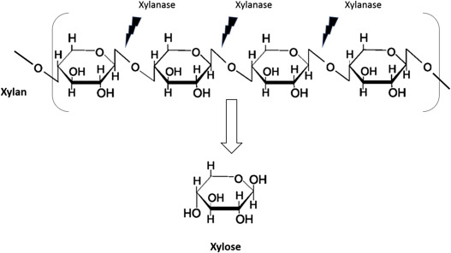

Materials Required:
- Birch Wood Xylan Agar plates (MgSO₄-0.05%, KCl-0.05%, K₂HPO₄-0.1%, NaNO₃-0.2%, Birch Wood Xylan 1%, Agar-2%, pH-7)
- Fresh soil sample collected in presterilized container
- Conical flasks
- Sterile Petridishes
- Sterile 1ml glass pipettes for serial dilution
- Glass spreader
- 5 culture tubes with 9 ml of sterile distilled water or saline water in each for serial dilution.
- Non absorbent cotton
- 70% alcohol as disinfectant
- 1% Congo red solution
- 1(N) NaCl solution
- Vortex
- Balance
- Spirit lamp
- Glass marker
- Autoclave
- Incubator
- Laminar air flow chamber

Procedure:
1. Collect fresh soil in clean and presterilized glass container and measure it as 1gm.
2. Prepare Birch Wood Xylan agar media, sterilize, aseptically add 20 ml in sterile Petriplates and allow those to be solidified.
3. Mark the serial dilution tubes as 10⁻¹, 10⁻², 10⁻³……upto 10⁻⁵.
4. Add 1 gram of soil aseptically to the first 9ml sterile water containing tube and mark it as 10⁻¹ dilution.
5. Vortex the tube for 2-3 min and allow the soil particles to settle by keeping the tube undisturbed for 5-10 min.
6. Using a sterile pipette transfer 1 ml of soil suspension from 10 ⁻¹ tube aseptically into the next dilution tube and shake it well. This is 10⁻² dilution.
7. Repeat the procedure of step 6 up to the dilution tube 10⁻⁵.
8. Take 0.1ml of suspension from the dilution tube (10 ⁻³, 10 ⁻⁴, 10 ⁻⁵) and place that onto the individual marked sterile Birch Wood Xylan agar plates aseptically (mark the dilution factor on plate and medium) and spread that using a sterile glass spreader.
9. Incubate the plates at 37⁰C for 2 days or till sufficient growth appears.
10. After incubation, add 1% Congo red solution to the Birch Wood Xylan agar plates and incubate for 15 min.
11. Discard the Congo red staining solution after 15 min and wash with 1 (N) NaCl solution.

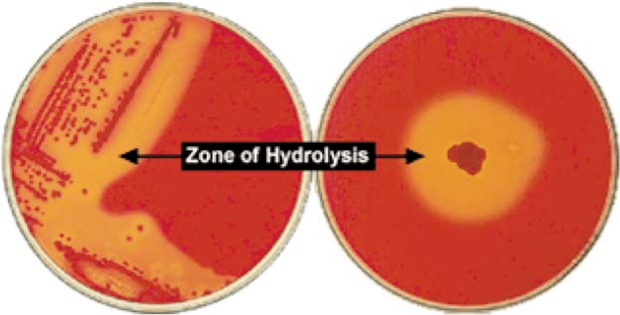
Plate showing xylan hydrolysis by the bacterial isolate
Observation:
- The appearance of yellow zone of hydrolysis around the colonies is an indication of positive xylanolytic activity.
Soil Sample | Dilution | Number of colonies with xylanase activity | Remarks
Sample A

Result:
Isolation of Lipase Producing Bacteria

Principle
Lipase (Triacylglycerol hydrolases EC 3.1.1.3) is an enzyme capable of hydrolyzing lipids into fatty acids and glycerol. It possesses many industrial applications such as pharmaceuticals, food, detergents, paper and pulp, agrochemicals, biosurfactants and bioremediation, etc, Microbial lipases have already established their vast potential regarding usage in numerous applications. Specifically they are employed in waste water treatment (degreasing of lipid clogged drains), pharmaceutical (resolution of racemic mixtures), dairy (hydrolysis of milk, fat), leather (removal of lipids from hides and skin), detergent (removal of oil/fat stains) and medical (diagnostic tool in blood triglyceride assay) industries.
Lipases can be produced from various sources, e.g., animals, plants and microorganisms. Microbial lipases attracted more attention due to its easy isolation, ease of genetic manipulation, high yield possible, systematic amount due to absence of seasonal variations and quick growth of microorganisms. Lipase producing bacterial strains are generally widespread in nature. Lipase producers have been isolated mainly from soil or spoiled food material that contain vegetable oil.
Lipase production test is based on the principle that lipolytic microorganisms will show a zone of lipolysis i.e. a clear area surrounding the bacterial growth when inoculated on Tributyrin agar medium. The loss of opacity of the agar medium is due to the hydrolytic reaction yielding soluble glycerol and fatty acids.

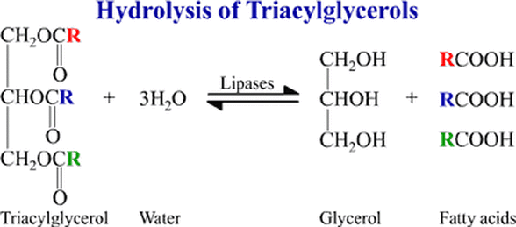

Materials Required:
- Tributyrin Agar Plates (Peptone-0.5%, Yeast extract or beef extract-0.3%, Ammonium nitrate-1%, K₂HPO₄-0.05%, KH₂PO₄-0.05%, Glucose 0.1%, Tributyrin-1% Agar-2%, pH-7-8)
- Fresh soil sample collected in presterilized container
- Conical flasks
- Sterile Petridishes
- Sterile 1ml glass pipettes for serial dilution
- Glass spreader
- 5 culture tubes with 9 ml of sterile distilled water or saline water in each for serial dilution.
- Non absorbent cotton
- 70% alcohol as disinfectant
- Vortex
- Balance
- Spirit lamp
- Glass marker
- Autoclave
- Incubator
- Laminar air flow chamber

Procedure:
1. Collect fresh soil in clean and presterilized glass container and measure it as 1gm.
2. Prepare Tributyrin agar media, sterilize, aseptically add 20 ml in sterile Petriplates and allow those to be solidified.
3. Mark the serial dilution tubes as 10⁻¹, 10⁻², 10⁻³……upto 10⁻⁵.
4. Add 1 gram of soil aseptically to the first 9ml sterile water containing tube and mark it as 10⁻¹ dilution.
5. Vortex the tube for 2-3 min and allow the soil particles to settle by keeping the tube undisturbed for 5-10 min.
6. Using a sterile pipette transfer 1 ml of soil suspension from 10 ⁻¹ tube aseptically into the next dilution tube and shake it well. This is 10⁻² dilution.
7. Repeat the procedure of step 6 up to the dilution tube 10⁻⁵.
8. Take 0.1ml of suspension from the dilution tube (10 ⁻³, 10 ⁻⁴, 10 ⁻⁵) and place that onto the individual marked sterile Tributyrin agar plates aseptically (mark the dilution factor on plate and medium) and spread that using a sterile glass spreader.
9. Incubate the plates at 37⁰C for 2 days or till sufficient growth appears.
Observation:
A positive lipid hydrolysis test will be indicated by the presence of clear area surrounding the colonies while no clearance around the colonies indicates negative reaction and the tributyrin agar medium retains its opacity because of the lack of secretion of extracellular hydrolytic enzyme lipase by the colonies.
Soil Sample | Dilution | Number of colonies with lipase activity | Remarks
Soil sample A

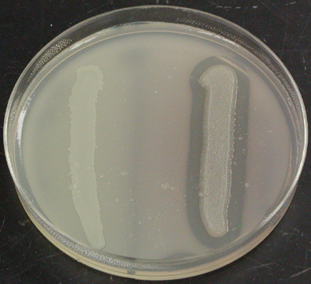
Lipase positive isolate showing zone of hydrolysis along the line of streaking
Lipase negative isolate showing no zone of hydrolysis along the line of streaking

Result:

Study of Yeast Single Cell Protein

Principle
Single Cell Protein (SCP) is a term coined in the 1960’s to embrace microbial biomass (yeast, fungi, algae and bacteria) products which were produced by fermentation. The dried cells of microorganisms or the whole organism is harvested and consumed as SCP. SCP production technologies arose as a promising way to solve the problem of worldwide protein shortage. They evolved as bioconversion processes which turned low value by-products, often wastes, into products with added nutritional and market value.
The pioneering research conducted almost a century ago by Max Delbruck and his colleagues first highlighted the value of surplus brewer’s yeast as a feeding supplement for animals and by 1960’s some quarter of a million tons of food yeast were being produced in different parts of the world to compensate agricultural protein production deficits. By 1980, SCP production processes were operating on a large scale in developed countries and plans to extend SCP production to underdeveloped countries were being made. Many low cost substrates (by products of various industries) like molasses, cheese whey, starch, spent sulfite liquor can be used for large scale production of yeast biomass. Yeasts have advantages such as their large size (easier to harvest), lower nucleic acid content, high lysine content and ability to grow at acidic pH. Disadvantages include lower growth rates, lower protein content (45 to 65%) and lower methionine content than bacteria.
After production yeast cells are recovered by decantation-centrifugation (including washing) and drying treatment methods. After washing, undesirable traces of medium are removed which can be again recycled for economic reasons. As a result of final harvesting by rotary vacuum filter a cake containing 20-40 per cent dry matter is obtained which is then dried to get a product of 6-10 per cent water content.

Materials Required:
- Molasses medium (Molasses-15%, Ammonium sulphate- 0.3%, Magnesium sulphate- 0.25%, Yeast extract, Potassium dihydrogen phosphate- 0.5%, pH-4.5-5)
- YPD medium
- Saccharomyces cerevisiae culture
- Conical flasks
- Test Tubes
- Non absorbent cotton
- Inoculation needle
- Balance
- Autoclave
- Laminar air flow chamber
- Incubator
- Centrifuge
- Aluminium cup
- Hot air oven
[N.B.- If molasses is not available perform the experiment with YPD medium and Glucose or Sucrose medium. The objective is to compare the yeast biomass production in various mediums.
Composition of Glucose medium- Glucose-10%, Potassium dihydrogen phosphate- 0.5%, Ammonium sulphate- 1.5%, Magnesium sulphate- 0.25%, Yeast Extract- 0.25%, pH-5
Composition of Sucrose medium- Sucrose-10%, Potassium dihydrogen phosphate- 0.1%, Ammonium sulphate- 0.5%, Magnesium sulphate- 0.05%, Yeast Extract- 0.1%, pH-4.5 ]
Procedure:
- Prepare 100 ml of any two types of mediums and dispense 2ml and 8ml of the mediums in two test tubes and the rest 90 ml in a 250ml conical flask and sterilize all of them by autoclaving.
- Inoculate the 2ml media with a single colony of S. cerevisiae cell suspension and incubate the test tube in a rotary shaker incubator with an agitation speed of 300 rpm at 35⁰C for 24 hr.
- After 24 hr. add this 2ml culture aspectically to the 8ml sterile medium and incubate the test tube again for 24 hr. in the same condition.
- Then add this 10ml culture aseptically to the 90 ml sterilized medium, mix well and incubate the flask in a rotary shaker incubator with an agitation speed of 300 rpm at 35⁰C for 48 hr.
- Repeat this scale up procedure for the second medium as well.
- After production recover the yeast cell from the medium by centrifuging the medium at 10,000 x g for 10 min.
- Wash the cells (pellet) with distilled water and again centrifuge at 10,000 x g for 10 min.
- Repeat step 7 twice to remove any traces of the medium.
- Mix the cells (pellet) with a minimum volume of distilled water and take this in an aluminium cup.
- Keep the obtained biomass in a hot air oven for 30 hr. at 65⁰C to obtain the dry yeast biomass.

Observation:
Determination of Biomass of yeast cells
Medium used | Weight of the empty cup (A) gm | Weight of cup + cell (wet weight) (B) gm | Weight of cup +dry weight of cell (C) gm | Final Biomass (C-A) gm

Result:

Study of Pigment Producing Microorganisms
Principle
The demand for natural colors is increasing day by day due to harmful effects of some synthetic dyes. Bacterial and fungal pigments provide a readily available alternative source of naturally derived pigments. The main sources for natural pigments are plants or microorganisms. The use of plant pigments has many drawbacks such as non-availability throughout the year and pigment stability and solubility. Large scale plant use may lead to loss of valuable species. For these reasons, the process may not consider viable. Microorganisms such as fungi and bacteria provide a readily available alternate source of naturally derived pigments. Apart from colorant, bacterial and fungal pigments possess many biological properties such as antioxidant, antimicrobial and anticancer activity. Bacterial and fungal pigments have extensive applications and have an enormous advantage over plant pigments, including easy and rapid growth in low cost medium, easy processing, and growth that is independent of weather conditions.
Microorganisms can produce both water soluble and insoluble pigments. Water soluble pigment produced by microorganisms diffuses from the organism into the medium. Water insoluble or sparingly soluble pigments remains associated with the cells.

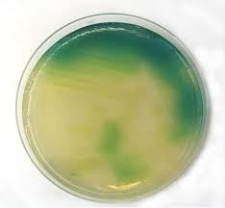
Water soluble ‘Pyocyanin’ produced by Pseudomonas aeruginosa

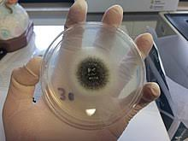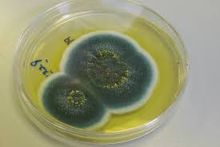
Black colored water insoluble pigment produced by the spores of A.niger
Green colored water insoluble pigment produced by the spores of P.notatum

Materials Required:
- Nutrient Agar Medium
- Czapekdox Agar Medium
- Aspergillus niger culture
- Penicillium notatum culture
- Pseudomonas aeruginosa culture
- Conical flasks
- Sterile Petriplates
- Non absorbent cotton
- Inoculation needle
- Balance
- Autoclave
- Laminar air flow chamber
- Incubator
Procedure:
- Prepare 50 ml of Nutrient Agar medium and 100ml of Czapekdoz Agar medium, sterilize both the mediums by autoclaving and aseptically pore 20-25ml of molten mediums in sterile Petriplates. In this way prepare 2 nutrient agar plates and 4 Czapekdox agar plates.
- With the help of sterile inoculation needle streak Pseudomonas aeruginosa culture onto the previously prepared nutrient agar plates and allow the plates to incubate at 37⁰C temperature for 36hrs.
- With the help of sterile inoculation needle streak Aspergillus niger and Penicillium notatum culture on previously prepared Czapekdox agar plates (2 plates for each culture) and incubate the plates at 30⁰C for 3-5 days.
- After incubation observe the plates for pigment formation by the respective organisms.

Observation:
Name of the organism | Color of the pigment produced | Nature of the pigment (Water soluble/water insoluble)
Pseudomonas aeruginosa
Aspergillus niger
Penicillium notatum

Result:

