25B.Sc (HONOURS) MICROBIOLOGY (CBCS STRUCTURE) CC-3: BIOCHEMISTRY (THEORY) SEMESTER –2 MCB-A-CC-2-3-TH TOTAL HOURS: 50 CREDITS: 4 Unit 1 Bioenergetics No. of Hours: 6 First and second laws of Thermodynamics. Definitions of Gibb’s Free Energy, enthalpy,and Entropy and mathematical relationship among them, Standard free energy change and equilibrium constant Coupled reactions and additive nature of standard free energy change, Energy rich compounds: Phosphoenolpyruvate, 1,3- Bisphosphoglycerate, Thioesters, ATP
Unit 2 Carbohydrates No. of Hours: 10 Families of monosaccharides: aldoses and ketoses, trioses, tetroses, pentoses, and hexoses. Stereo isomerism of monosaccharides, epimers, Mutarotation and anomers of glucose.Furanose and pyranose forms of glucose and fructose, Haworth projection formulae for glucose; chair and boat forms of glucose, Sugar derivatives, glucosamine, galactosamine, muramic acid, N- acetyl neuraminic acid, Disaccharides; concept of reducing and non-reducing sugars, occurrence and Haworth projections of maltose, lactose, and sucrose, Polysaccharides, storage polysaccharides, starch and glycogen. Structural Polysaccharides, cellulose, peptidoglycan and chitin
Unit 3 Lipids No. of Hours: 10 Definition and major classes of storage and structural lipids.Storage lipids.Fatty acids structure and functions.Essential fatty acids.Triacylglycerols structure, functions and properties. Saponification Structural lipids.Phosphoglycerides: Building blocks, General structure, functions and properties. Structure of phosphatidylethanolamine and phosphatidylcholine, Sphingolipids: building blocks, structure of sphingosine, ceramide. Special mention of sphingomyelins, cerebrosides and gangliosides Lipid functions: cell signals, cofactors, prostaglandins, Introduction of lipid micelles, monolayers, bilayers
Unit 4 Proteins No. of Hours: 10 Functions of proteins, Primary structures of proteins: Amino acids, the building blocks of proteins. General formula of amino acid and concept of zwitterion. Titration curve of amino acid and its Significance, Classification, biochemical structure and notation of standard protein amino acids Ninhydrinreaction.Natural modifications of amino acids in proteins hydrolysine, cystine and hydroxyproline, Non protein amino acids: Gramicidin, beta-alanine, D-alanine and D- glutamic acid Oligopeptides: Structure and functions of naturally occurring glutathione and insulin and synthetic aspartame, Secondary structure of proteins: Peptide unit and its salient features. The alpha helix, the beta pleated sheet and their occurrence in proteins, Tertiary and quaternary structures of proteins. Forces holding the polypeptide together. Human haemoglobin structure, Quaternary structures of proteins
Unit 5. Enzymes Structure of enzyme: Apoenzyme and cofactors, prosthetic group-TPP, coenzyme No. of Hours: 10 NAD,metal cofactors, Classification of enzymes, Mechanism of action of enzymes: active site, transition state complex and activation energy. Lock and key hypothesis, and Induced Fit hypothesis. Significance of hyperbolic, double reciprocal plots of enzyme activity, Km, and allosteric mechanism Definitions of terms – enzyme unit, specific activity and turnover number, Multienzymecomplex : pyruvate dehydrogenase; isozyme: lactate dehydrogenase, Effect of pH and temperature on enzyme activity. Enzyme inhibition: competitive- sulfa drugs; non-competitive-heavy metal salts
Unit 6. Vitamins Classification and characteristics with suitable examples, sources and importance

Name “ Enzyme “ Introduced by Frederick W. Kuhne.
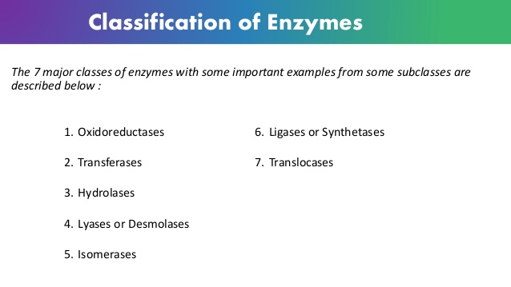

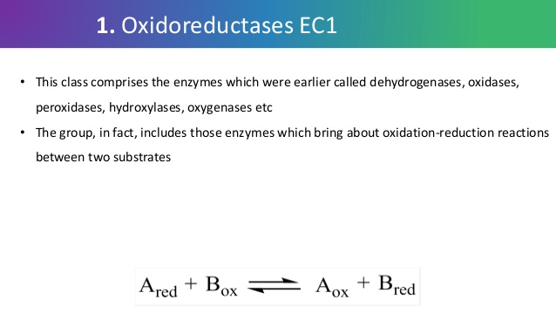

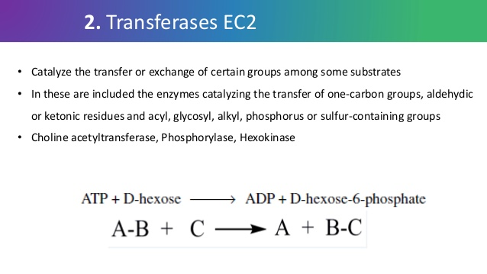
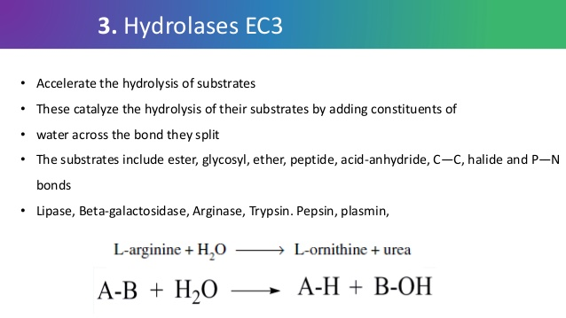

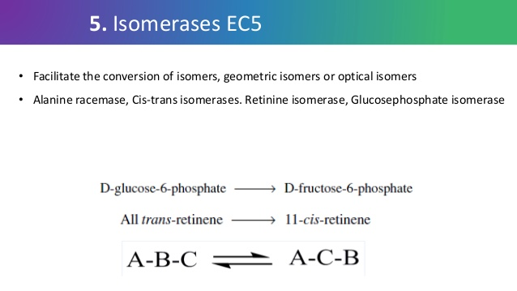

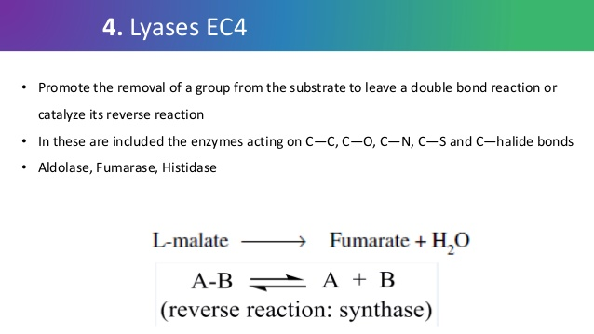

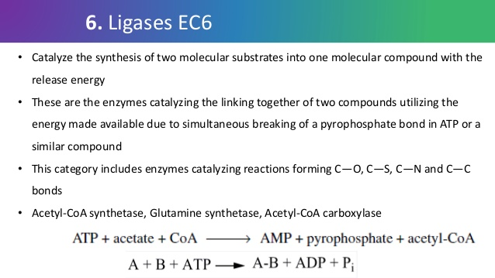

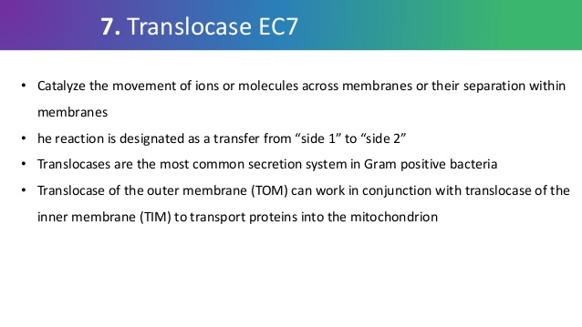
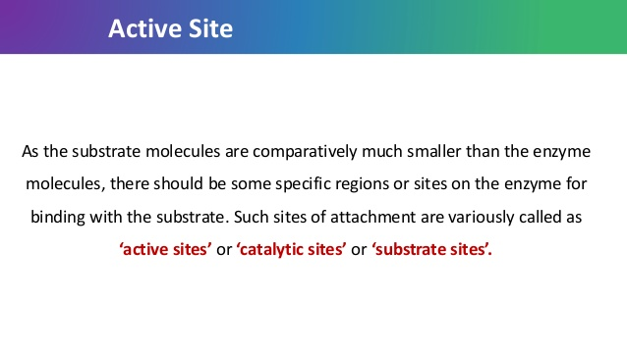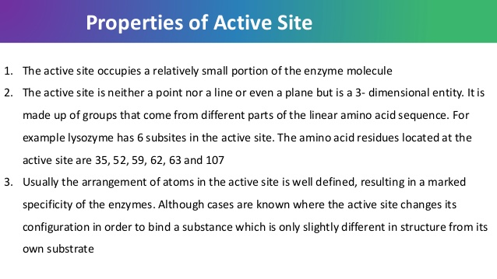
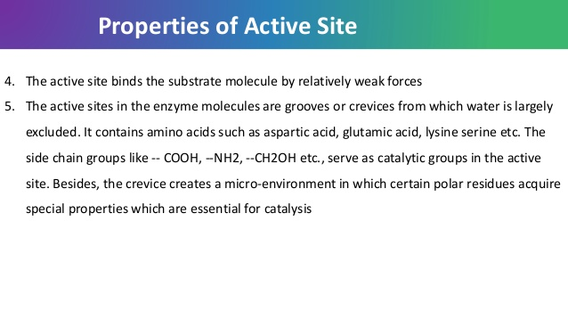
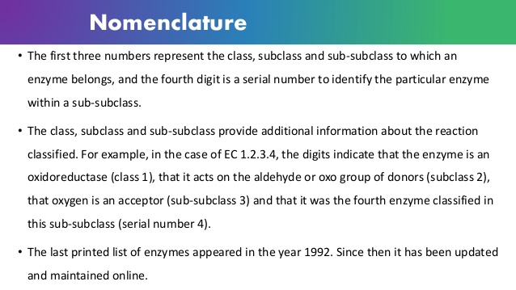

Holo enzyme = Apo enzyme / Apo protein + Cofactor
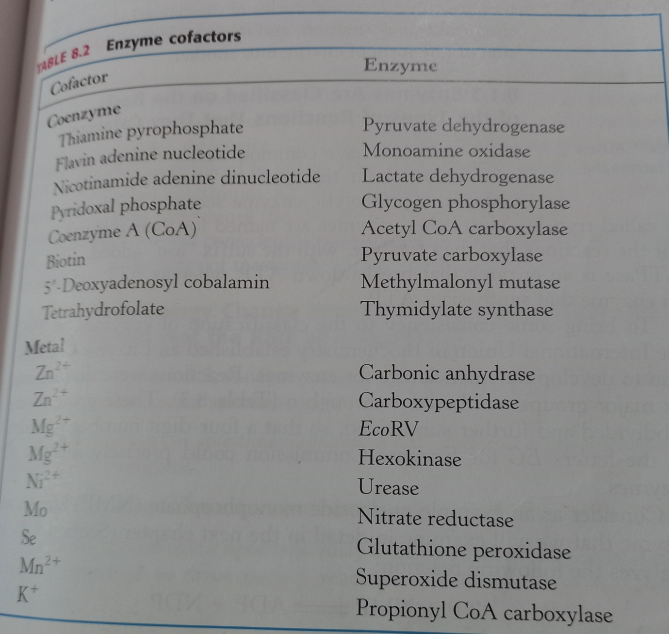
Enzyme affect reaction rates, not equilibria
E + S = ES= EP= E + P

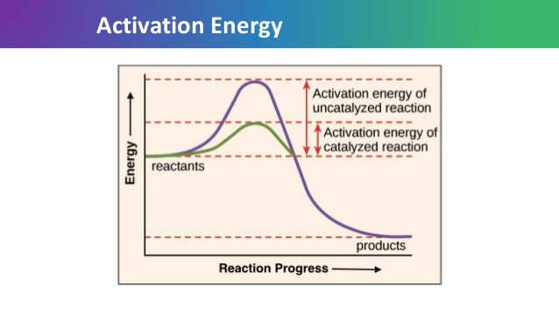

Standard free energy change for the reaction is negetive means the free energy of the ground state of Product is lower than that of substrate. So Δ G is negetive for the equilibrium which favors the formation of product.
Transition State: A molecular moment in which events such as bond breakage , bond formation, charge development have proceeded to the precise point at which decomposition to either substrate or product is equally likely.
Activation Energy: The difference between the energy level of the ground state and the transition state is called activation energy.
Catalysis enhances the reaction rate by lowering the activation energy.

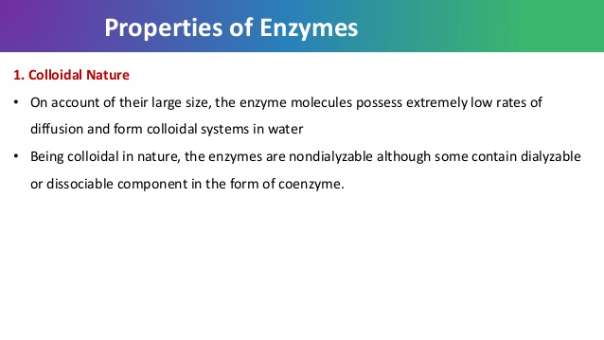

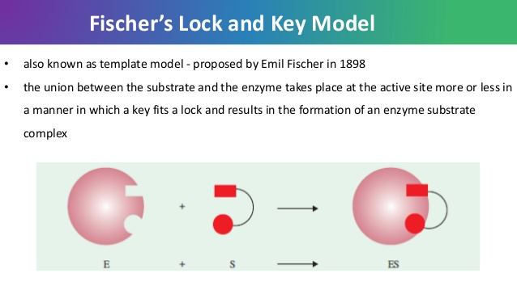

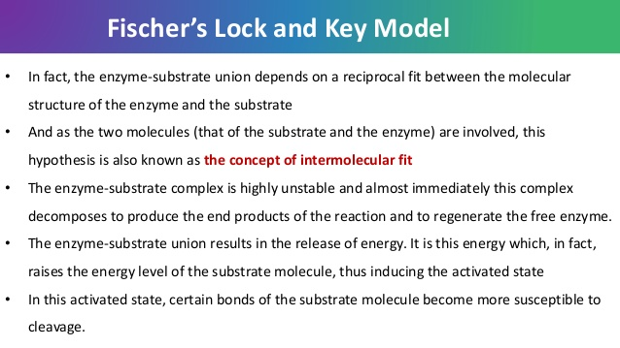

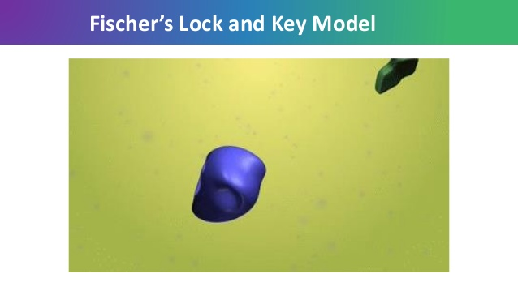
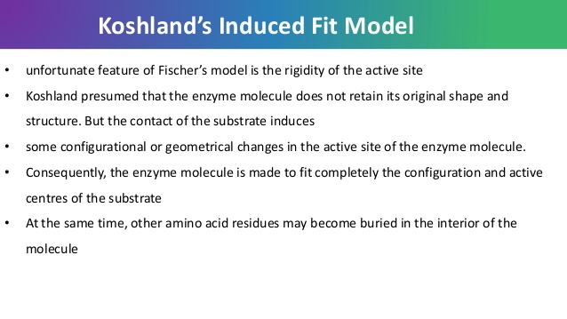
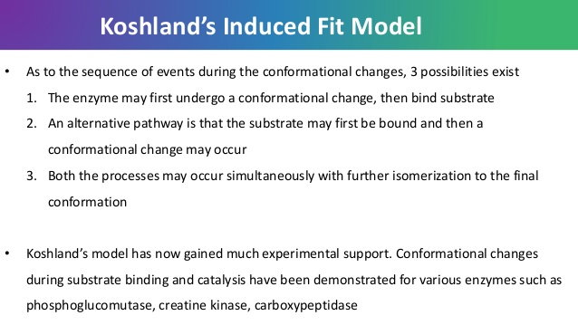

Enzyme is complementary to transition state.

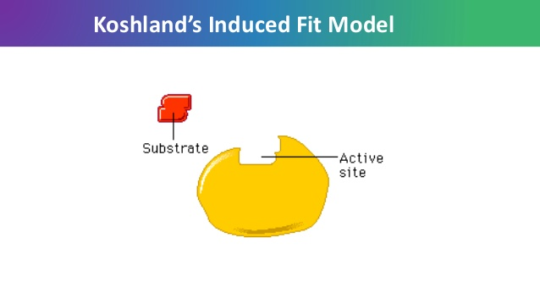
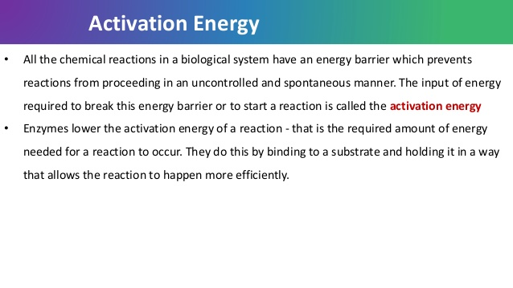
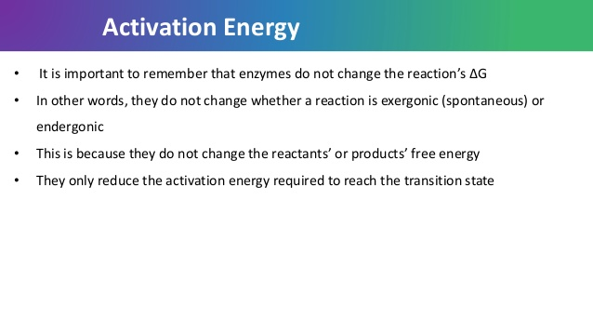
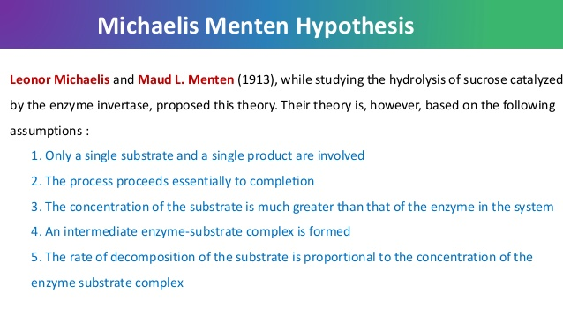

E+S=ES K1. K-1, ES= EP K2, K-2, EP = E+ P K3

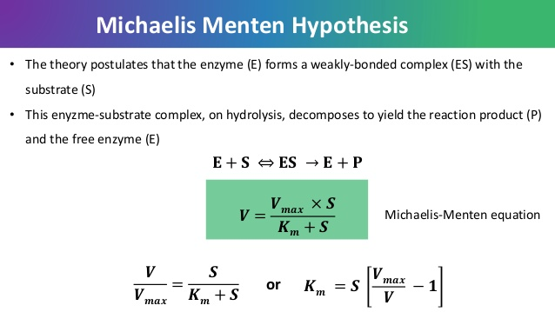

1/v = Km + S / V max xS
1/V = Km/ Vmax x S + 1/Vmax
The Lineweave r–Burk plot puts 1/[S] on the x-axis and 1/V on the y-axis.

.

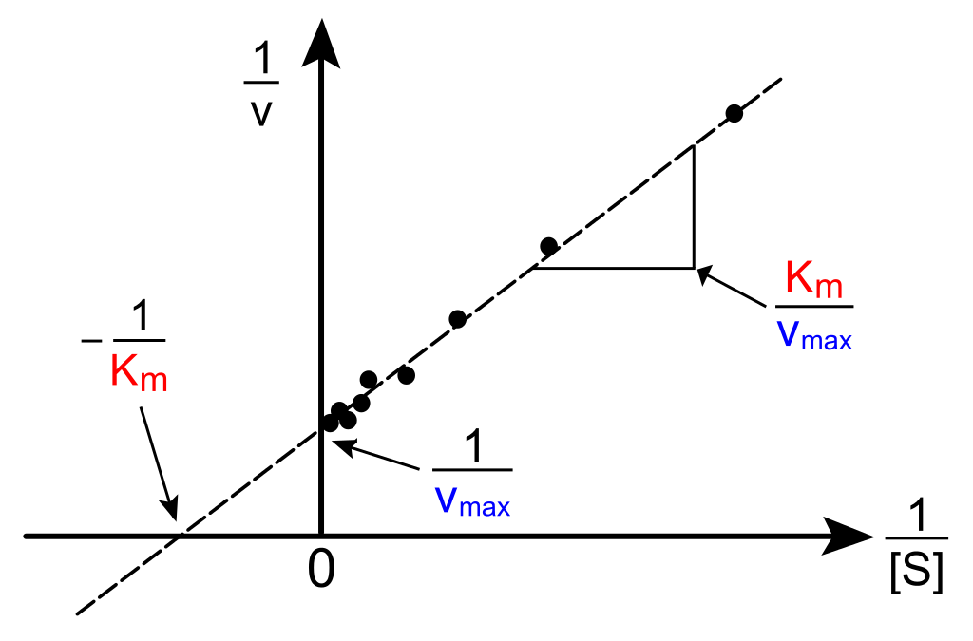

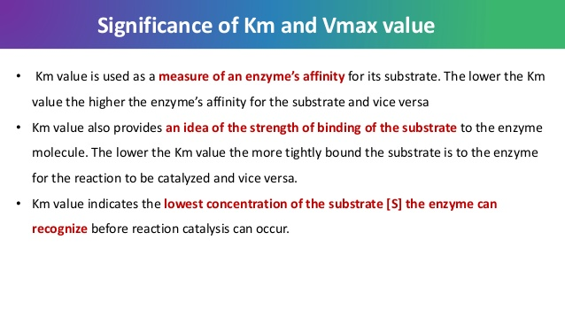
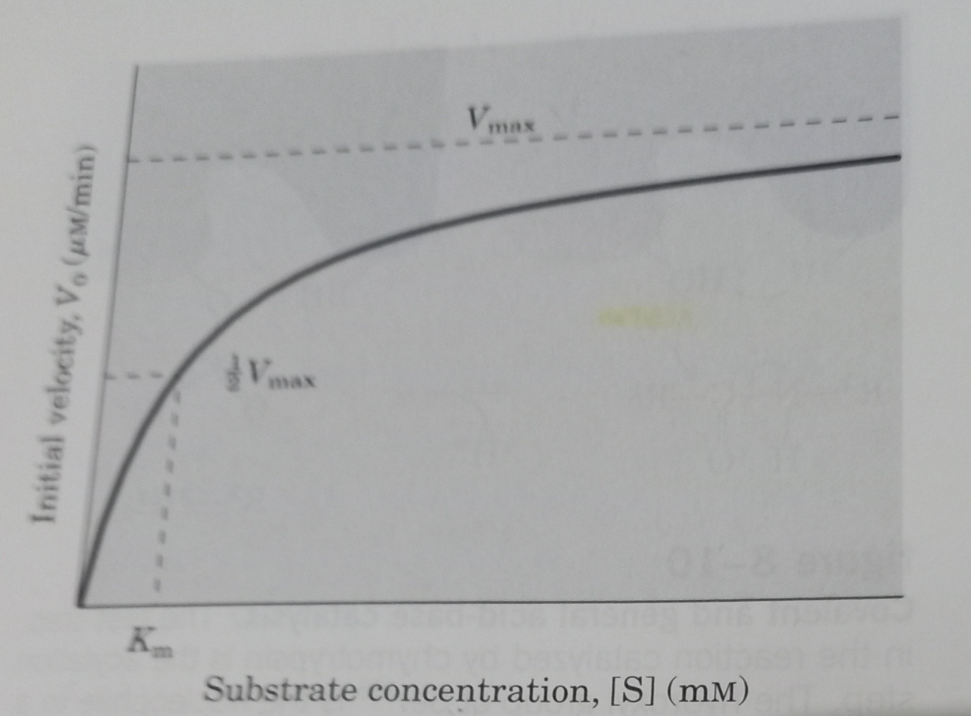
Unit Of Km = M ( molar) / mM ( milli molar) / µM ( micromolar)
Unit of Vmax = Amount of product formed per unit time : micromole / minute
Biochemical reactions involving a single substrate are assumed to follow Michaelis-menten equation.
Kcat / turn over number: number of substrate molecules converted to product in a given unit time on a single enzyme molecule when the enzyme is fully saturated with substrate.
Kcat = Vmax/[ET]., unit = Second⁻¹

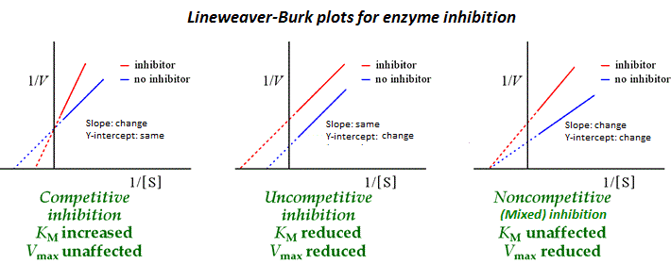
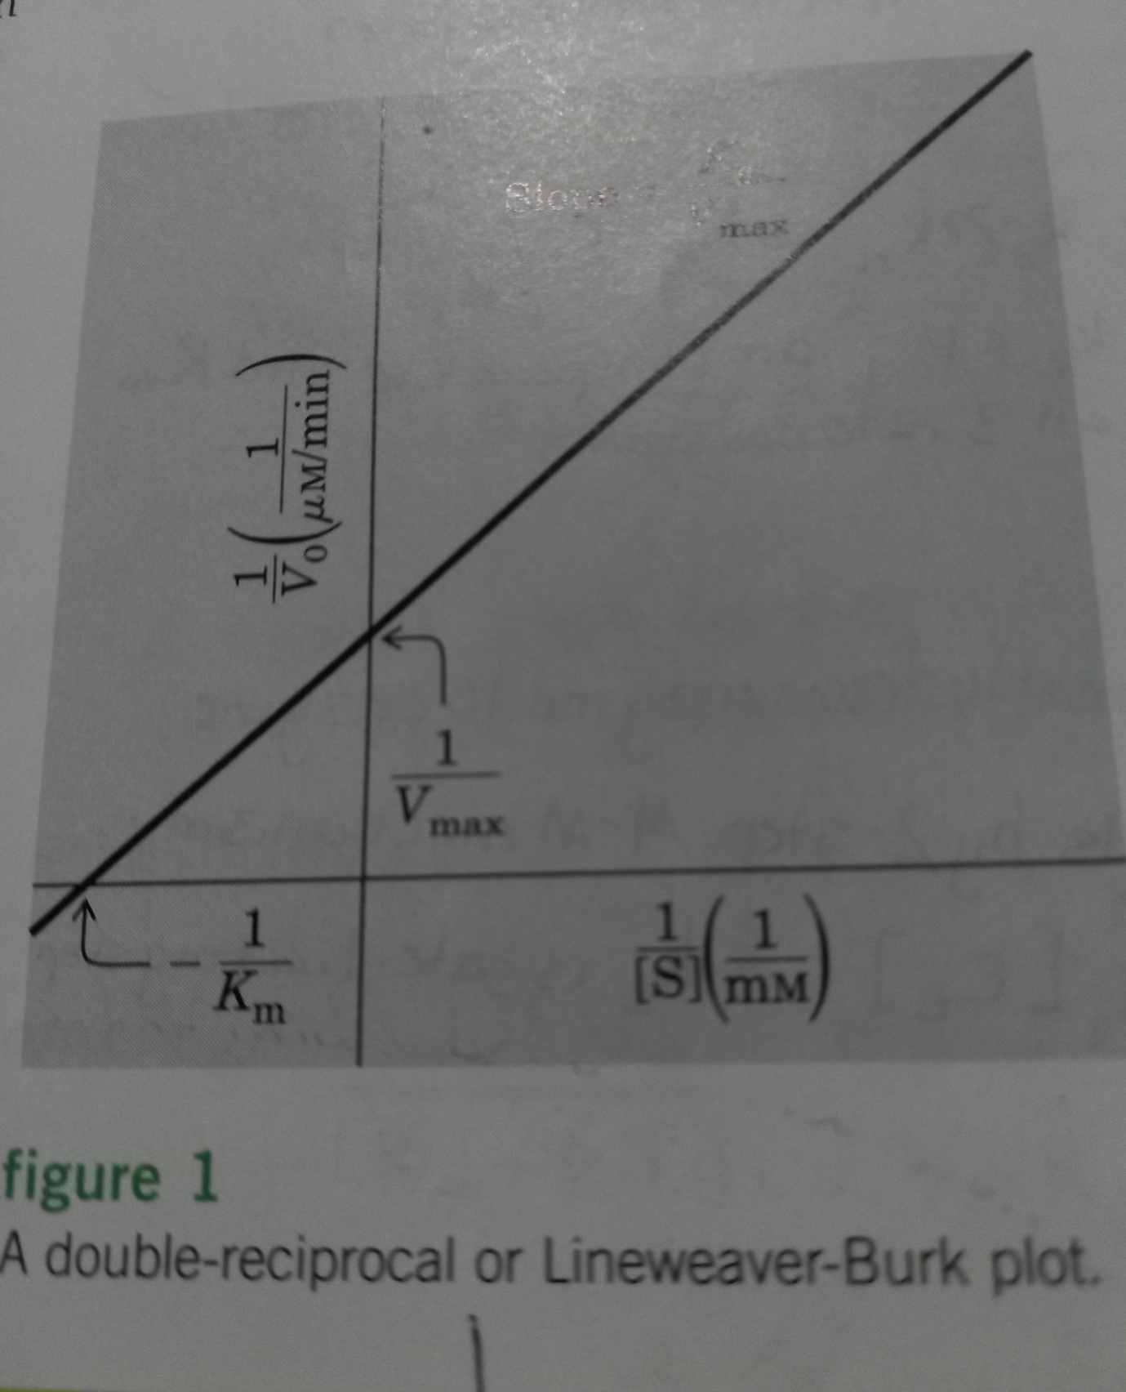
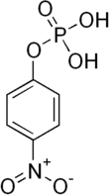
Substrate concentration = 1mM
371.15 g / 1000 substrate is present in 1000 ml solvent for preparation of 1Mm solution
1000ml 1mM substrate solution contains 371.15/1000 g
1ml 1mM substrate solution contains 0.37115/1000 g
50 ml 1mM substrate solution contains 0.37115/1000g x 50
0.1M Glycine-NaOH buffer, pH 9.8
Para nitro phenyl P + Buffer = Paranitro phenol + inorganic P ( Pi)
Substrate concentration : 1 mM ( milli molar) , Total volume = 50ml, how much substrate will be required to prepare 50 ml substrate solution?
Substrate concentration in tube no 1 =
V1 xS1 = V2 XS2
V1= 0.1ml
V2 = 1ml
S1 = 1mM
S2 = 0.1 x 1 ml x mM/ 1ml
1---S2 = 0.1mM 1/S2 = 1/0.1mM = 10mM⁻¹
2---- S2 = 0.2 mM
3---- S2 = 0.4 mM
4----S2 = 0.6 mM
5----S2 =0 .8mM
Velocity = Product formed per minute = product formed / 30min
Micro mole
Tube no | Buffer ( ml) | Enzyme ( ml) | Substrate ( ml)
Blank | 0.8 | --- | 0.2
1 | 0.7 | 0.2 | 0.1
2 | 0.6 | 0.2 | 0.2
3 | 0.4 | 0.2 | 0.4
4 | 0.2 | 0.2 | 0.6
5 | 0.1 | 0.2 | 0.7
Temp= 37degree C, Time of incubation = 30min
After 30 min of incubation 2ml 1M NaOH solution will be added to each tube
At 440nm optical density is observed.
Preparation of standard curve of para nitro phenol
Stock concentration of para nitro phenol = 0.1mM ( milli molar)
Mol wt of para nitro phenol = 138.1 gm
Calculate the amount of para nitro phenol to prepare 0.1mM 25 ml solution.
0.1milli mole of paranitro phenol is present in 1000ml solution
138.1g/10000 paranitro phenol is present in 1000ml solution
1ml solution requires 138.1g/ 10000000 paranitro phenol
25 ml solution requires 138.1 x 25 g/ 10⁷ =3452.5 g/ 10⁷
Test tube no | Volume of paranitro phenol  ( ml) | Volume of NaOH ( 1M)  (ml)
Blank | ---- | 3
1 | 0.1 | 2.9
2 | 0.2 | 2.8
3 | 0.4 | 2.6
4 | 0.6 | 2.4
5 | 0.8 | 2.2

Tube No | [S] micro molar | 1/ [S] micro molar-1 | V (micromole/min) | 1/V (micromole/min)-1
1 | 100
2 | 200
3 | 400
4 | 600
5 | 800

Para nitro phenol standard curve
TubeNo | Amount of Para nitro phenol ( µmole/ml) micromole per millilitre | Optical density at 440 nm
Blank | 0.0 | 0.0
1 |  | 0.102
2 |  | 0.202
3 |  | 0.350
4 |  | 0.452
5 |  | 0.660
 | ---

TubeNo | Concentration of paranitro phenol ( µg/ml)
Blank | 0.0
1 | 50
2 | 100
3 | 200
4 | 400
5 | 800
unknown | ---

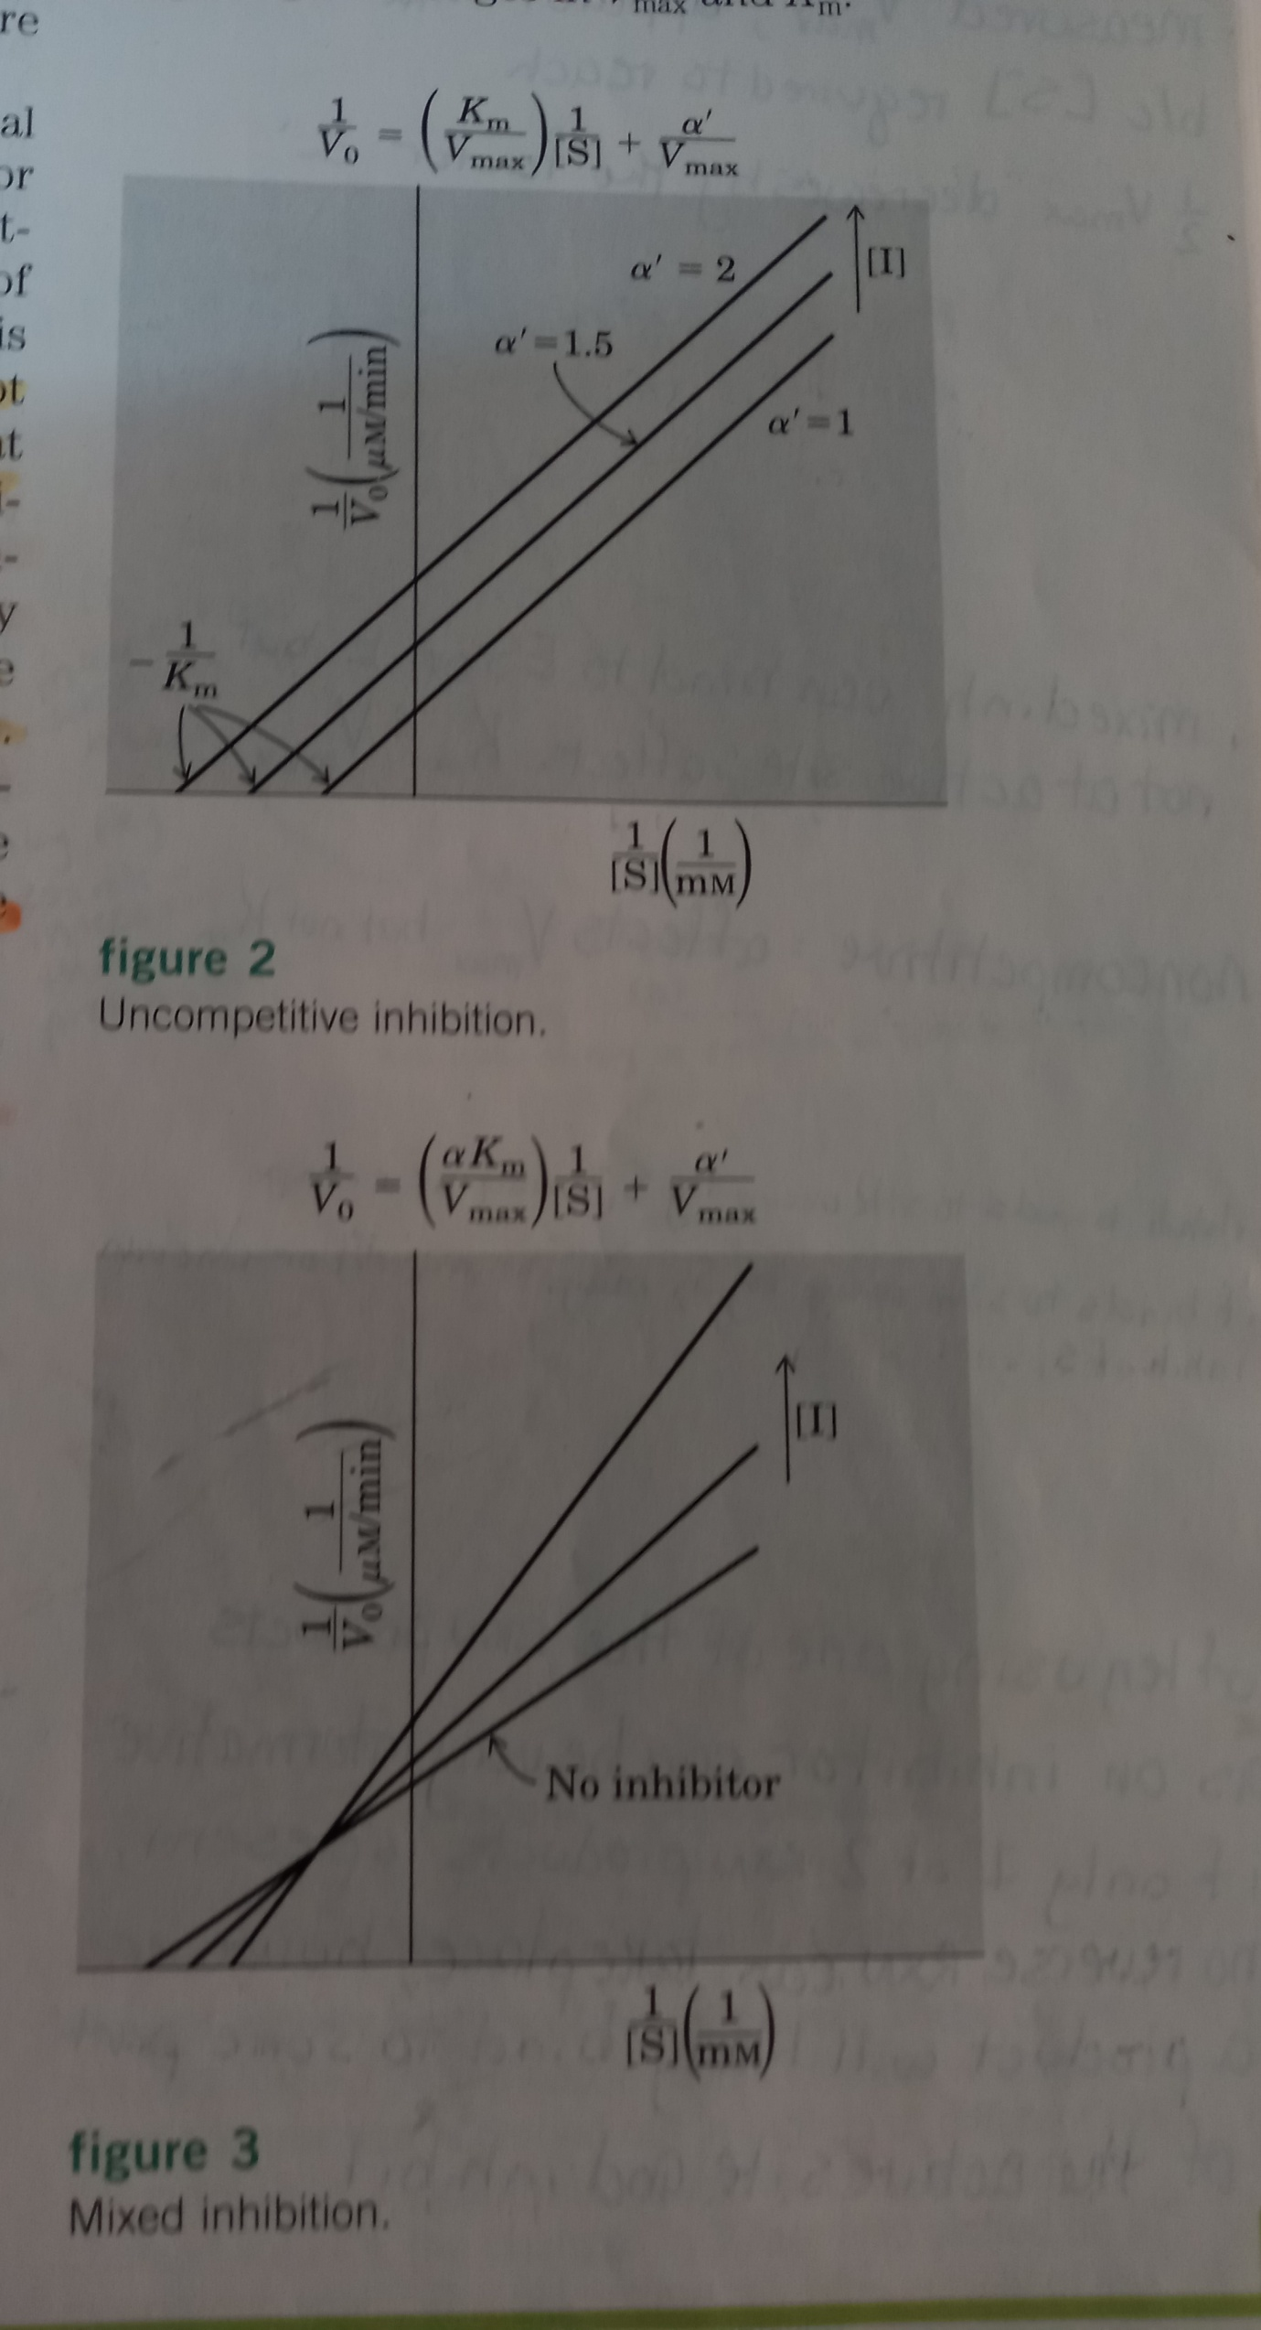

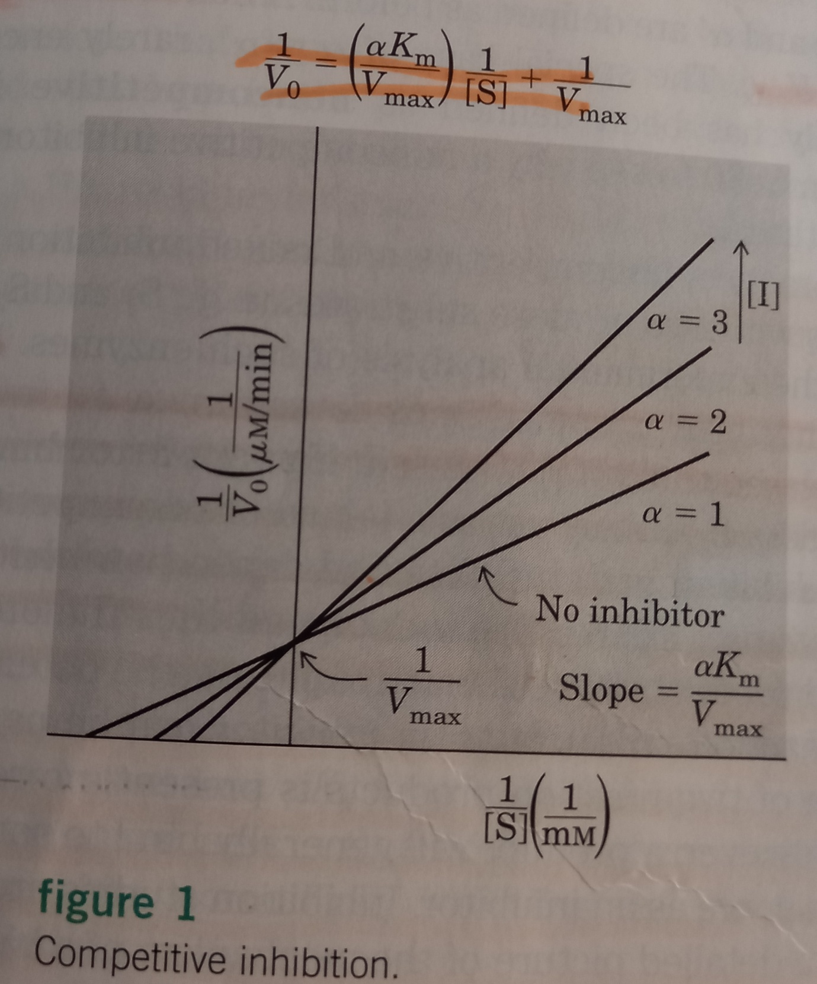

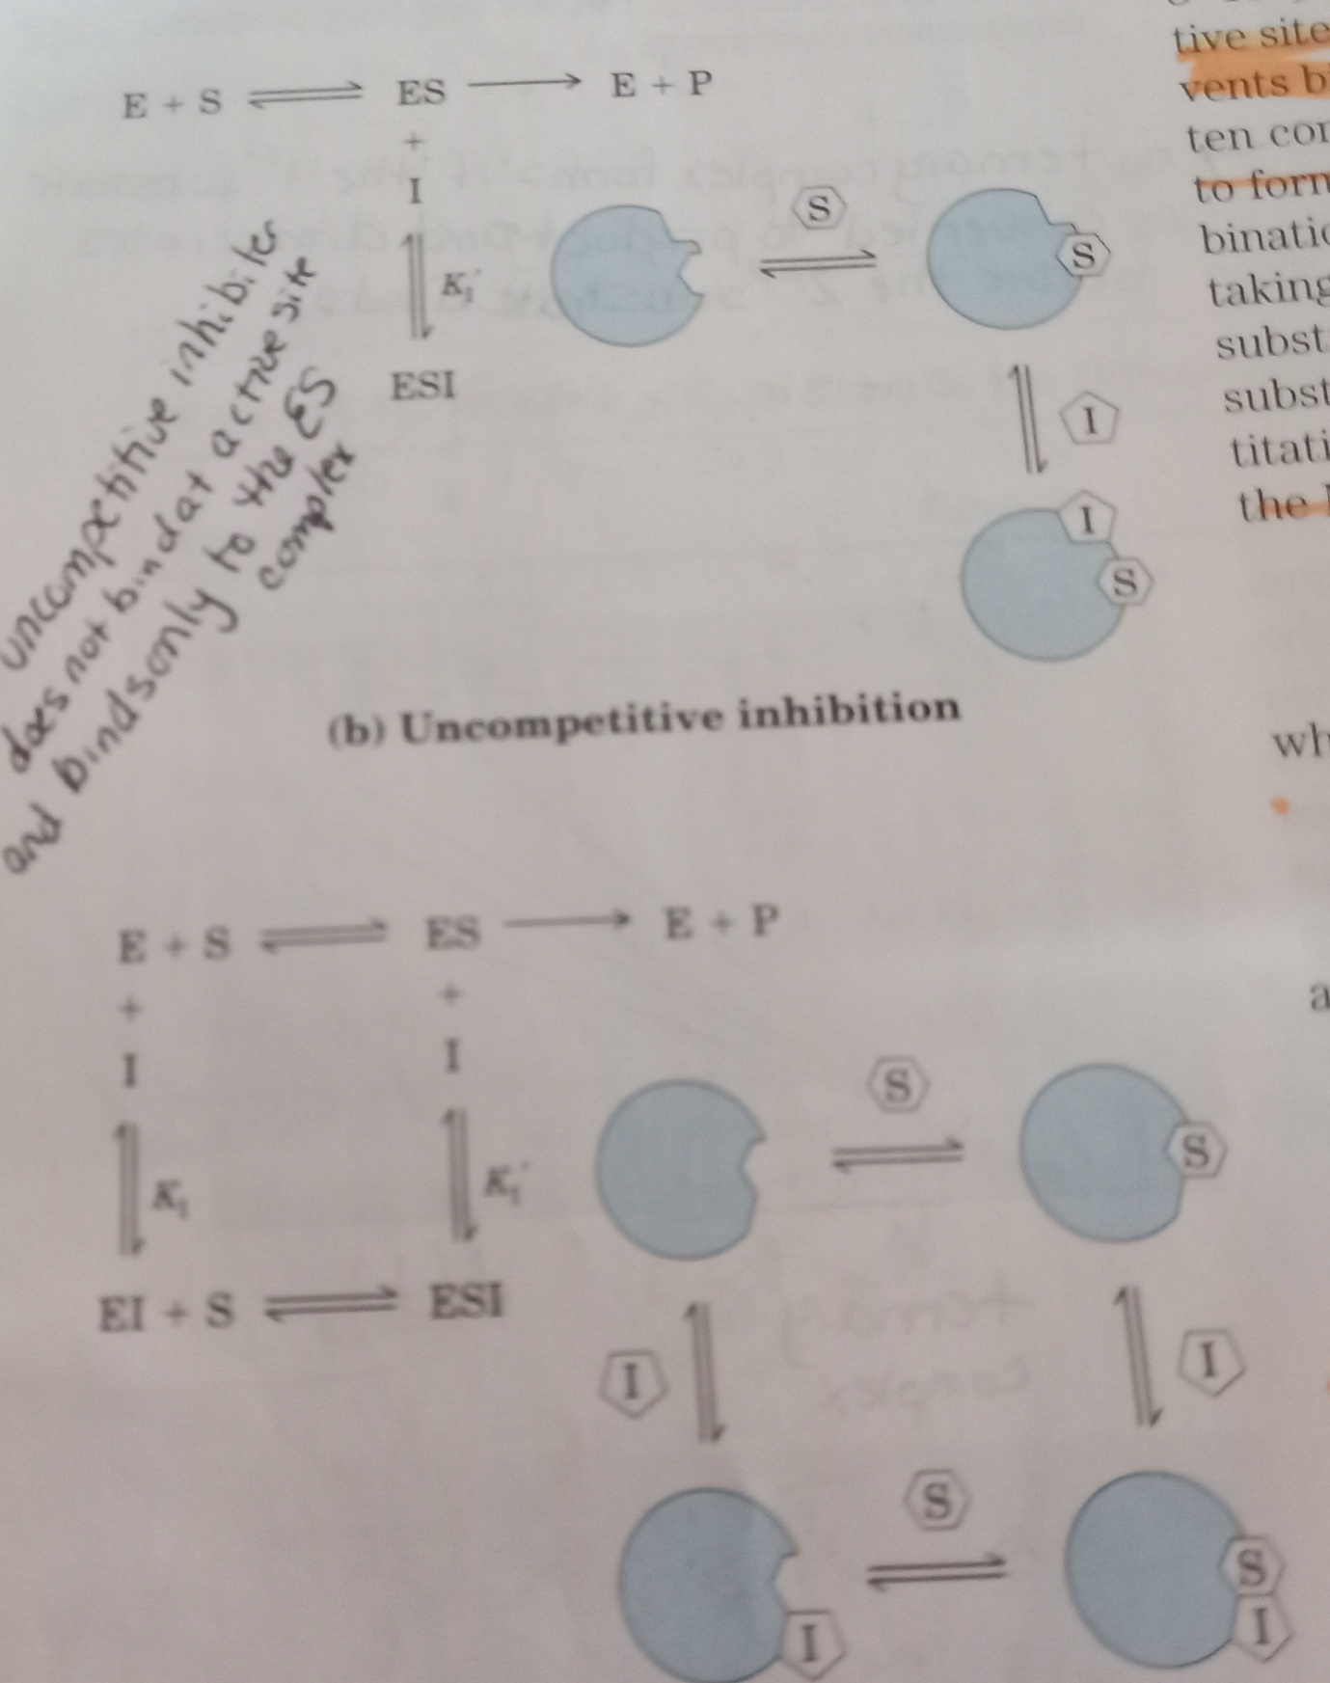

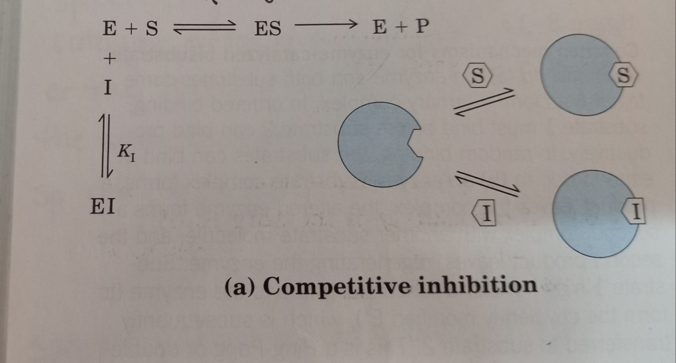

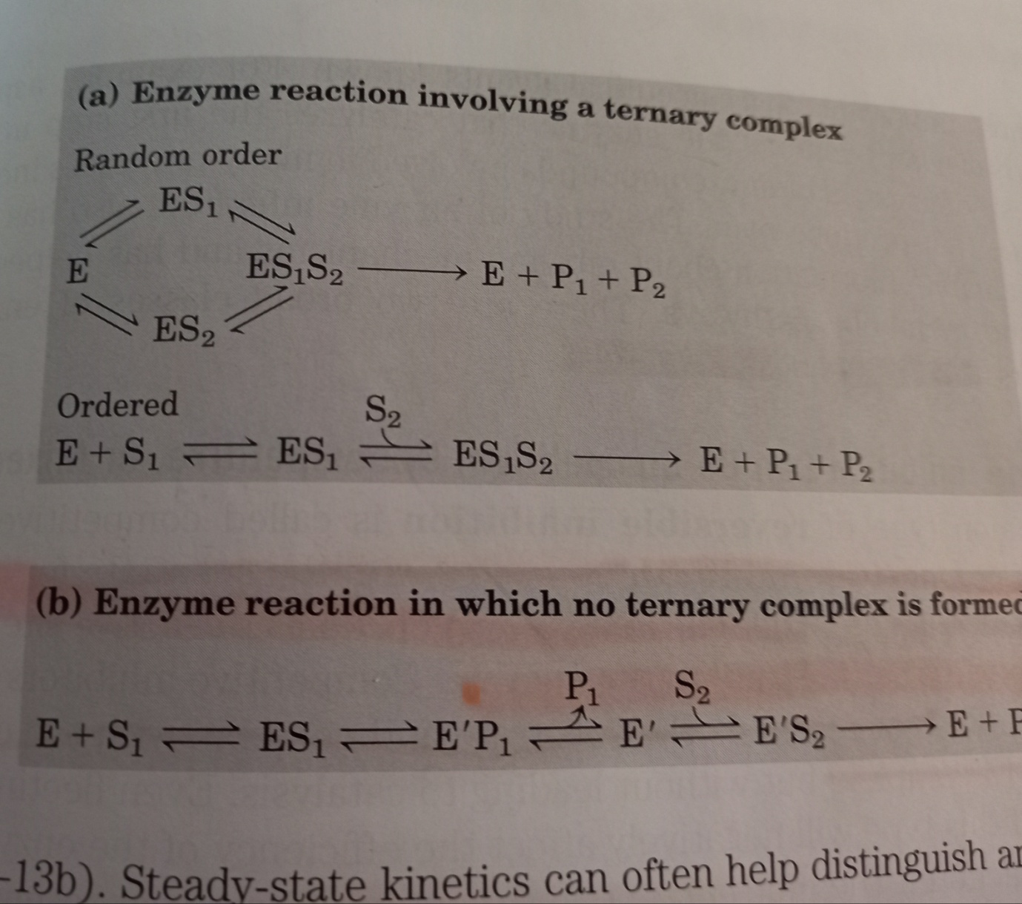

 | Competitive | unncompetitive | Noncompetitive
Inhibitor binding | Occupies the active site | Binds at a site distinct from the substrate active site, binds only ES complex | Binds at a site distinct from the substrate active site, it will bind either E or ES
Michaelis Menten Equation | V0 = Vmax[S]  αKm +S  α = 1+ [I]  K_{I}  K_{I} = [E][I]  [EI]
Apparent Km (αKm) | Increses by the factor α | Deceases Km value | When binds E, effect is like competitive inhibition and binds ES , the effect is like uncompetitive inhibition
Apparent Vmax | Vmax remains same | Vmax value decreses
Excess substrate concentration

Irreversible inhibitors
An irreversible inhibitor will bind to an enzyme so that no other enzyme-substrate complexes can form. It will bind to the enzyme using a covalent bond at the active site which therefore makes the enzyme denatured. An example of an irreversible inhibitor is diisopropyl fluorophosphate which is present in nerve gas. It binds to the enzyme and stops nerve impulses being transmitted. An example of where we use irreversible inhibitors in medicine is penicillin. Penicillin works by inhibiting the activity of the enzyme responsible for the creation of the bacterial cell wall. This means that water can enter the bacterial cell, causing it to swell, burst and die termed lysis

Irreversible Inhibitor:
Group-specific reagents: Reacts with specific R group of amino acid.
Diisopropyl phosphofluoridate (DIPF)
Affinity labels: They are the molecules which are structurally similar to the substrate for the enzyme that covalently modify active site residue.
3-bromoacetol is an affinity label molecule for the enzyme Triose phosphate isomerise ( TIM). It mimics the normal substrate, dihyroxy acetone phosphate., by binding at the active site, then it covalently modifies.
Suicide inhibitor: Generates a chemically reactive intermediate that inactivates the enzyme through covalent modification. N, N-dimethylproperagylamine is inhibitor of Mono amine Oxidase ( MAO), the flavin prosthetic grp is being alkylated by this inhibitor at N5 position. MAO deaminates dopamine .
Penicillin irreversibly inactivates a key enzyme for bacterial cell wall synthesis.
Name of the inhibitors | Name of substrate | Enzyme | Type of inhibition
Methotrexate | Tetrahydrofolate | Dihydrofolate reductase | Competitive
Diisopropylphosphofluoridate | Inhibitors of enzymatic hydrolysis | Acetylcholinesterase | Irreversible
Bromoacetol phosphate | Conversion of Dihydroxyacetone phosphate to glyceraldehydes 3 phosphate | Triosephosphate isomerase | Irreversible
N,N-dimethylpropargyl amine | Deamination of Dopamine or serotonine | Monoamineoxidase | Irreversible
Penicillin | Cross-linking during bacterial cell wall synthesis | Transpeptidase | Irreversible
Malonate | Inhibits the conversion of succinate to fumarate in TCA cycle | Succinate dehydrogenase (Complex II) | Competitive inhibitor
Arsenate | Function of alkaline phosphatase | Alkaline phoshatase | Competitive inhibitor

Isozyme or Isoenzymes are enzymes that differ amino acid sequence yet catalyze the same reaction.Usually , these enzymes display different kinetic parameters, such as KM, or different regulatory properties. They are encoded by different genetic loci, which usually arise through gene duplication and divergence.
LDH-1: Present primarily in cardiac myocytes and erythrocytes.
▪
LDH-2: Present mostly in white blood cells.
▪
LDH-3: Present in highest quantity in lung tissue.
▪
LDH-4: Highest amounts found in pancreas, kidney, and placenta.
▪
LDH-5: Highest amounts found in liver and skeletal muscle.

Effect of pH

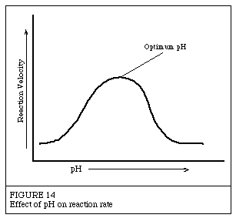

Effect of temperature

